**Inspirations and Moodboards**

A **mood board** is a design-related method to showcase a vision for pretty much anything. It involves making digital or physical collages that capture the essence of the mood, vibe, or reality you want to create.

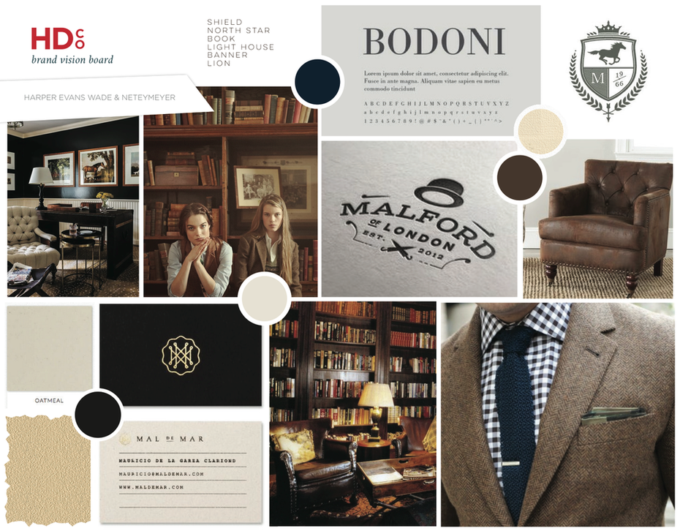

(image source: 99designs)

A mood board can be as simple as a poster board collage of images, drawings, colour schemes, words, typography, and any other design elements that visually convey a mood or sentiment. It can also be more high-tech and high-quality, leveraging a mood board template (also called a mood-board maker, a mood-board template, or a brand board template). (source: [Adobe Spark](https://www.adobe.com/express/learn/blog/creative-lookbook-and-mood-board-designs))

In the following video lesson, I will talk about the importance of getting inspiration and will explain some good practices to develop a visually appealing Mood board.

<https://youtu.be/9qpt0uHSmXw>

**Some Moodboard Creation Apps**

1. [**Pinterest**](https://www.pinterest.ca/)[**https://www.pinterest.ca/**](https://www.pinterest.ca/)

**2.** [**Milanote**](https://milanote.com/)[**https://milanote.com/**](https://milanote.com/)

**3.** [**Invision**](https://www.invisionapp.com/inside-design/boards-share-design-inspiration-assets/)[**https://www.invisionapp.com/inside-design/boards-share-design- inspiration-assets/**](https://www.invisionapp.com/inside-design/boards-share-design-%20%20%20%20inspiration-assets/)

**4.** [**niice.co**](https://niice.co/)[**https://niice.co/**](https://niice.co/)

**5.** [**Dragdis**](https://bookmarkos.com/)[**https://bookmarkos.com/**](https://bookmarkos.com/)

**6.** [**Canva**](https://www.canva.com/create/mood-boards/)[**https://www.canva.com/create/mood-boards/**](https://www.canva.com/create/mood-boards/)

**Some Inspirational Resources**

1. Design blogs: [Brand New](https://www.underconsideration.com/brandnew/), [BP&O](https://bpando.org/) <https://bpando.org/>

2. [SiteInspire.com](https://www.siteinspire.com/) <https://www.siteinspire.com/>

3. [typewolf.com](https://www.typewolf.com/) <https://www.typewolf.com/>

4. [The Dieline](https://thedieline.com/?) <https://thedieline.com/>?

5. [Awwwards](https://www.awwwards.com/) <https://www.awwwards.com/>

6. [Designspiration](https://www.designspiration.com/) <https://www.designspiration.com/>

7. [Muz.li](https://muz.li/) <https://muz.li/>

8. Books, signage, art, movies, nature, etc

**Some Image sources**

